Yolanda Brown- Module 3.2

Git Link - <https://github.com/ybrown30/csd-340.git>

Landing page - https://github.com/ybrown30/csd-340/blob/b912988bd9d052ad6e699b55b047cb4677d24cc2/index.html

HTML Validator

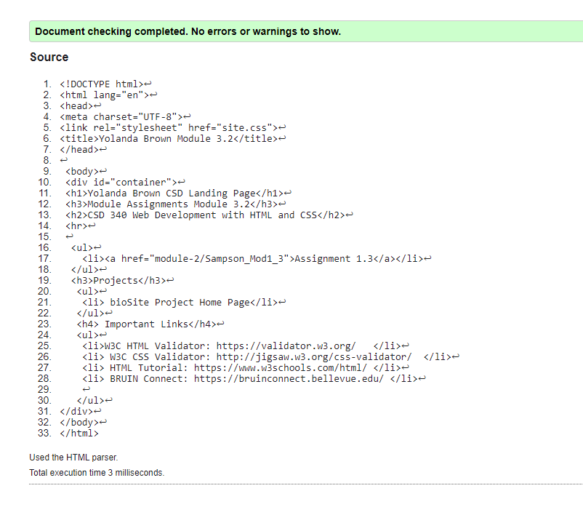

CSS Validation

